Assignment #3 Name: Tarun Banda

Program 1: Salary.java

**Screenshot (Sample Run) :**

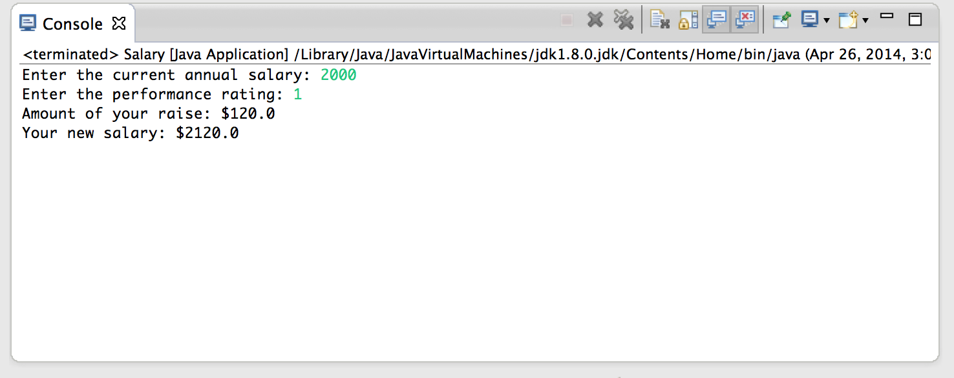

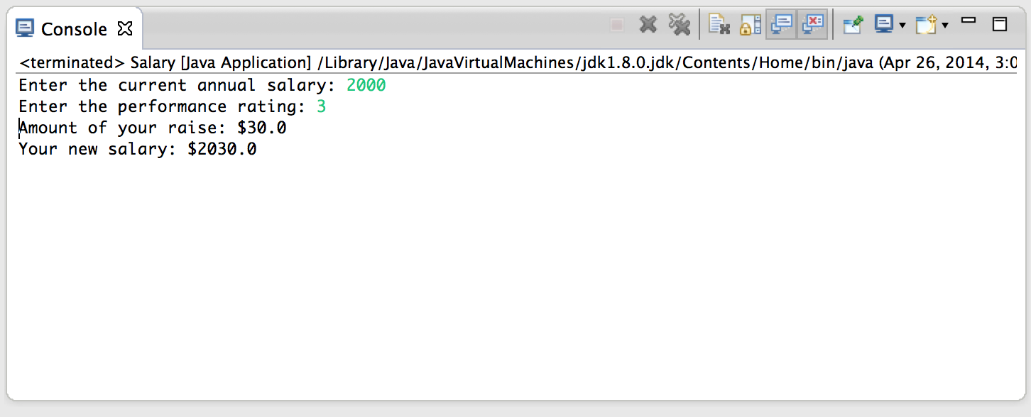

Program 2: CurrencyExchange.java

**Screenshot (Sample Run:**

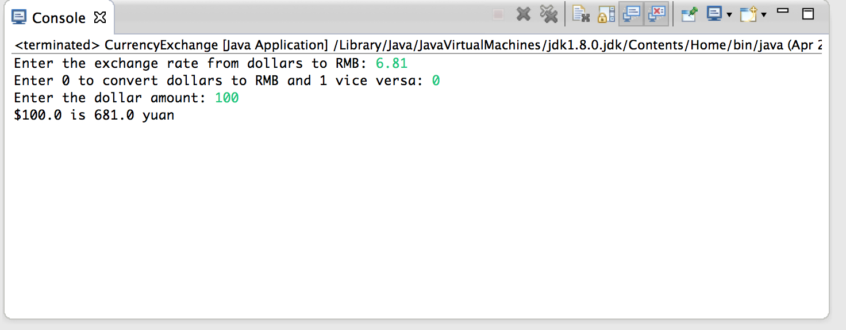

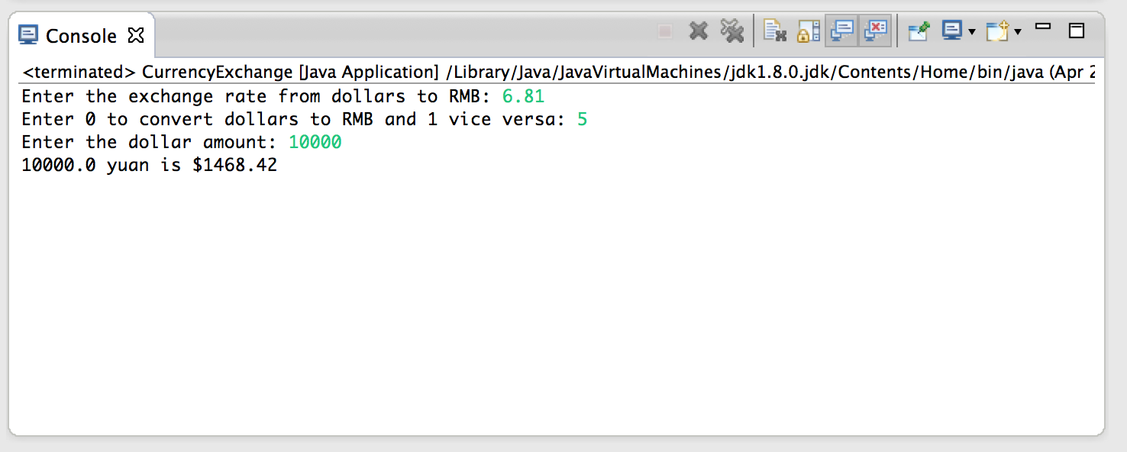

Program 3: SoftwareSales.java

**Screenshot (Sample Run):** GIVE IMAGE screen shot of the program running

